**Ex.No : 12**

**SQL STATEMENT WITH EXISTS,ANY,ALL**

1.Find the courses which have taken by students

Ans)

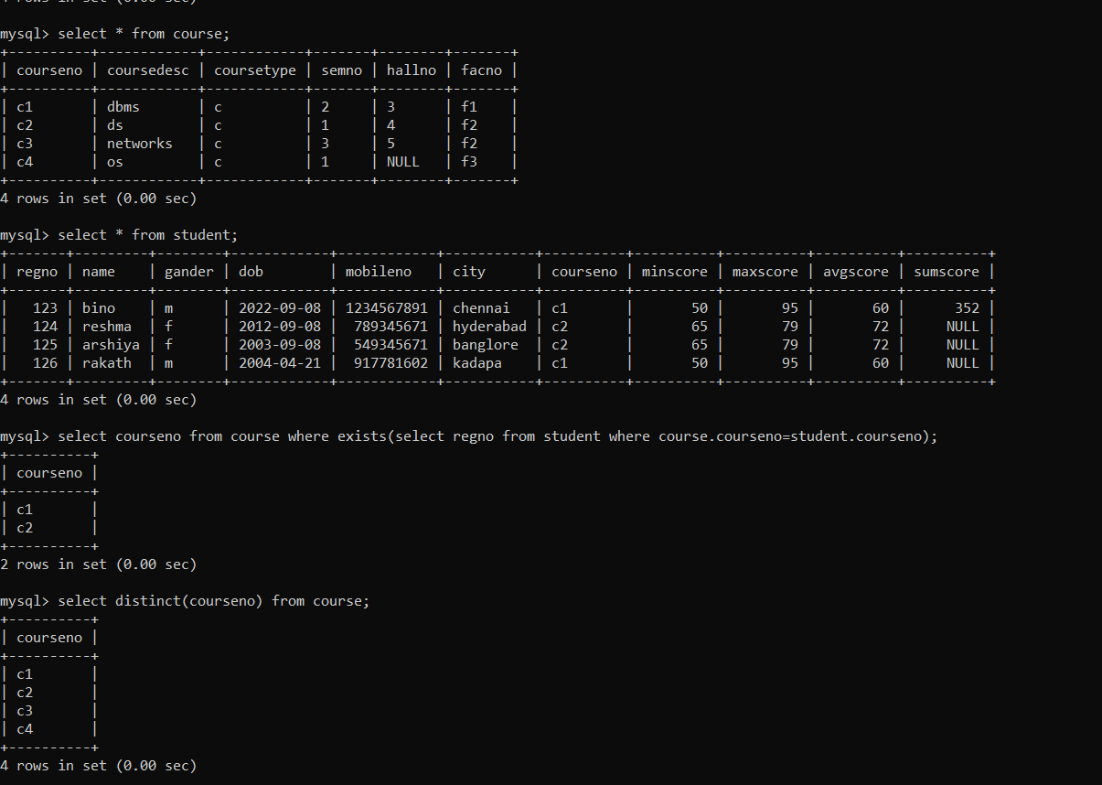

2.Find the Faculties to whom courses are assigned

Ans)

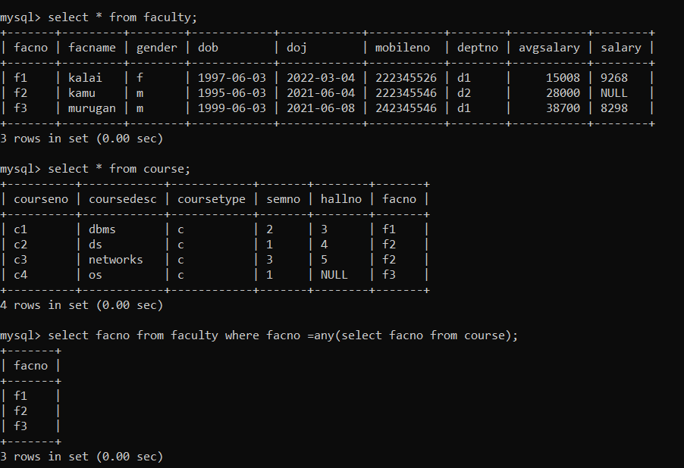

3.Find the d1 dept employess whose salary is greater than all the d2 dept employees salaries

Ans)

